Case 4-Eur-Switzerland-La Tène Celtic Culture-Spectacle Brooch-300-60 BCE

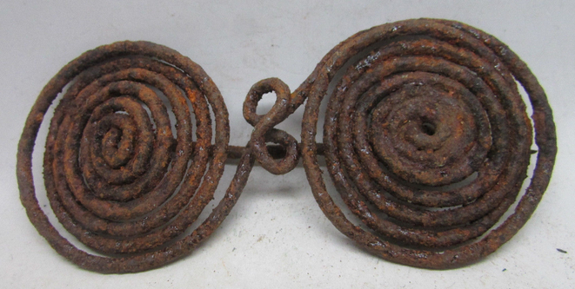 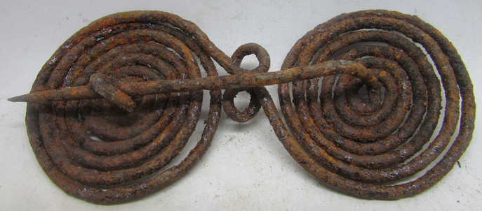

Figs. 1-2. Eur-Switzerland-La Tène Celtic Culture-Spectacle Brooch-300-60 BCE

**Case no.: 4**

**Accession Number:**

**Formal Label:** Eur-Switzerland-La Tène Celtic Culture-Spectacle Brooch-300-60 BCE

**Display Description:**

The La Tène Iron Age Celtic culture was named after the Swiss archaeological site of La Tène, Marin-Epagnier Canton, on the north side of Lake Neuchâtel, dating to 300-60 BCE.  This site was discovered in 1858 by Hansli Kopp who found previously submerged wooden pilings that were identified as Iron Age house platforms by Ferdinand Keller (1868).

Among later discoveries were 385 double-spiral brooches like this one. The brooch was made from a hammered sheet of iron into a cylinder about a yard long. Then the iron was heated and curled into the spiral shapes. The significance of the design of this brooch is cosmological, because it offers a symbol for eternity and for a prolonged life of the wearer: the unending passing of the Sun through the heavens.

This brooch’s Sun imagery is associated with **Sol Invictus** or the "Sun Invincible" which on the winter solstice December 25, 274 CE, Emperor Aurelian named as an additional cult of the Roman Empire. Sol Invictus was also a cult of Roman Legionnaires because it was believed that to believe in **the invincible Sun** guaranteed *their* invincibility on the battlefield. In this respexct **Sol Invictus**  was not a reformulation of the ancient [Latin](https://en.wikipedia.org/wiki/Latins_(Italic_tribe)) cult of [Sol](https://en.wikipedia.org/wiki/Sol_(mythology)),[[3]](https://en.wikipedia.org/wiki/Sol_Invictus#cite_note-3) a revival of the cult of [Elagabalus](https://en.wikipedia.org/wiki/Elagabalus_(deity)),[[4]](https://en.wikipedia.org/wiki/Sol_Invictus#cite_note-4) or completely new.[[5]](https://en.wikipedia.org/wiki/Sol_Invictus#cite_note-5) The god was favored by emperors after Aurelian and appeared on their coins until [Constantine I](https://en.wikipedia.org/wiki/Constantine_the_Great).[[6]](https://en.wikipedia.org/wiki/Sol_Invictus#cite_note-6) The last inscription referring to Sol Invictus dates to AD 387,[[7]](https://en.wikipedia.org/wiki/Sol_Invictus#cite_note-7) and there were enough devotees in the fifth century that the Christian theologian [Augustine](https://en.wikipedia.org/wiki/Augustine_of_Hippo) found it necessary to preach against them.[[8]](https://en.wikipedia.org/wiki/Sol_Invictus#cite_note-8)

This brooch is composed of two mirror image spirals that can be interpreted as depicting the shadow of the sun described by a gnomon for a year. In the summer solstice the spiral cast by the Sun’s shadow is clockwise and in the winter solstice the spiral cast by the Sun’s shadow is counter-clock wise. These two spirals were known as “the horns of the solstices” in pre-modern times. These brooches also suggest that the deposition of these brooches in Lake Neuchatel were ceremonial votive objects for a prolonged life. This interpretation explains why so many Iron Age swords both sharpened and blanks were also deposited in the Lake at this site. These were the weapons of warriors who hoped for a successful battle and a prolonged life: by throwing their weapons in the Neuchatel waters they were metaphorically baptizing them and their owners in the waters of eternal life.



Fig, Double spiral figures of the Sun’s shadow in the winter and summer solstices cast by a gnomon over a year.

**LC Classification:** [GN780.2.L3](http://josiah.brown.edu/search~S7?/c1-SIZE+GN780.2.L3+N38/cgn++780.2+l3+n38/-3%2C-1%2C0%2CE/frameset&FF=cgn++780.2+l3+n38&1%2C1%2C)

**Date or Time Horizon:** 200-60 BCE

**Geographical Area:** north side of Lake Neuchâtel within Marin-Epagnier's communal boundaries in Switzerland

**Map:**

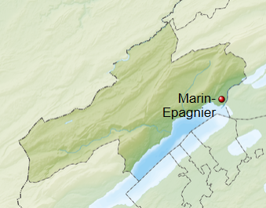

**GPS coordinates:** [47°01′N 7°01′E](https://tools.wmflabs.org/geohack/geohack.php?pagename=Marin-Epagnier&params=47_01_N_7_01_E_region:CH-NE_type:city)

**Cultural Affiliation:** Celtic La Tène culture

**Medium:** Iron

**Dimensions:** 3.5 in

**Weight:**

**Condition: original**

**Provenance:** The first systematic lowering of the Swiss lakes occurred from 1868 to 1883. This brooch was found on the north side of Lake Neuchâtel within Marin-Epagnier's communal boundaries probably in 1880.

**Discussion:**

Over 2500 mostly metal objects were recovered from La Tène, including 166 swords mostly mint, 270 lance heads, and 385 brooches (like this one), dating from 300 to 60 BCE (Megaw and Megaw 2001: 132-133). Based on the evidence of this brooch and its cosmological interpretation we suggest that La Tène functioned as a ceremonial place both before battles when swords and lances and brooches were thrown into the lake for good luck and after battles when the bodies of the dead were committed to the waters *in memoriam*.

**References:**

Cunliffe, Barry. 1997. *The Ancient Celts*. Oxford: Oxford University Press. 1997

Collis, John. 2003. *The Celts: Origins, Myths, Invention*. London: Tempus, 2003.

Garrow, Duncan (ed), 2008. *Celtic Art, Reading the Messages*, London: The Everyman Art Library.

Halsberghe, Gaston. 1972. *The cult of Sol Invictus*. Leiden: Brill.

James, Simon. 1999. *The Atlantic Celts*. London: British Museum Press.

James, Simon & Rigby, Valery. 1997. *Britain and the Celtic Iron Age*. London: British Museum Press.

Laffon, Robert. 2000. *Les Celtes, histoire et dictionnaire. Des origines à la romanisation et au christianisme.* Paris.

Laing, Lloyd and Jenifer. 1992. *Art of the Celts*, London: Thames and Hudson.

McIntosh, Jane. 2009. *Handbook to Life in Prehistoric Europe*. New York: Oxford University Press.

Megaw, Ruth and Vincent. 1989. *Celtic Art*. London: Thames and Hudson.

Reginelli Servais, Gianna and Béat Arnold, 2007. *La Tène, un site, un mythe*, Hauterive : Laténium - Parc et musée d'archéologie de Neuchâtel. Cahiers d'archéologie romande de la Bibliothèque historique vaudoise, 3 vols.